# [Microsoft](http://huskytech.uconn.edu/software/) Windows and Office

Students are eligible for Windows 10 Operating Systems and Microsoft Office 2016 or 2019. This software is distributed through <http://uconn.onthehub.com/>.

Install Project, Visio, Windows 10, and server OSes from <http://s.uconn.edu/imagine> please follow this link:

**Note:** Microsoft Project and Microsoft Visio are not available for macOS. Students with Macs will have to install and configure the Windows 10 Learning Environment, see links at the bottom of the page), and license Office 2019 Professional Plus for Windows prior to installing Project 2019 32 bit or Visio 2019 32 bit.

## Azure Development Tools for Teaching (formerly Imagine…Dreamspark)

1. Visit the Azure Dev Tools for Teaching page.
2. Click Sign In.
   1. Enter your UConn email in the **Email** field, Click **Next**.
3. Enter your NetID password, Click Sign In.
4. The Developers Tools page will open.

**IMPORTANT:** **Please install either Office 2016 OR Office 2019 32bit. Do not install 64-bit version.** Choose the same version Office 2019 32-bit, Project 2019 32-bit and Visio 2019 32-bit. **Your Office Suite version and bitness must match the extended Office Suite applications version and bitness**. For example: Project 2016 32-bit will only install correctly if Office 2016 32-bit is installed. An example of a version and bitness mismatch would be installing Office 2019 64-bit and Project 2016 32-bit.

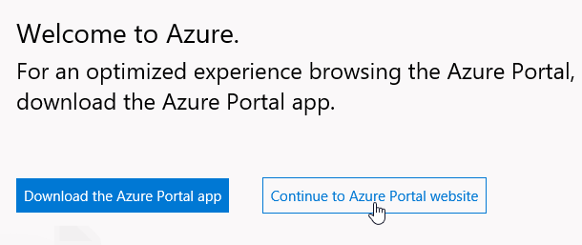

Click Continue to Azure Portal website

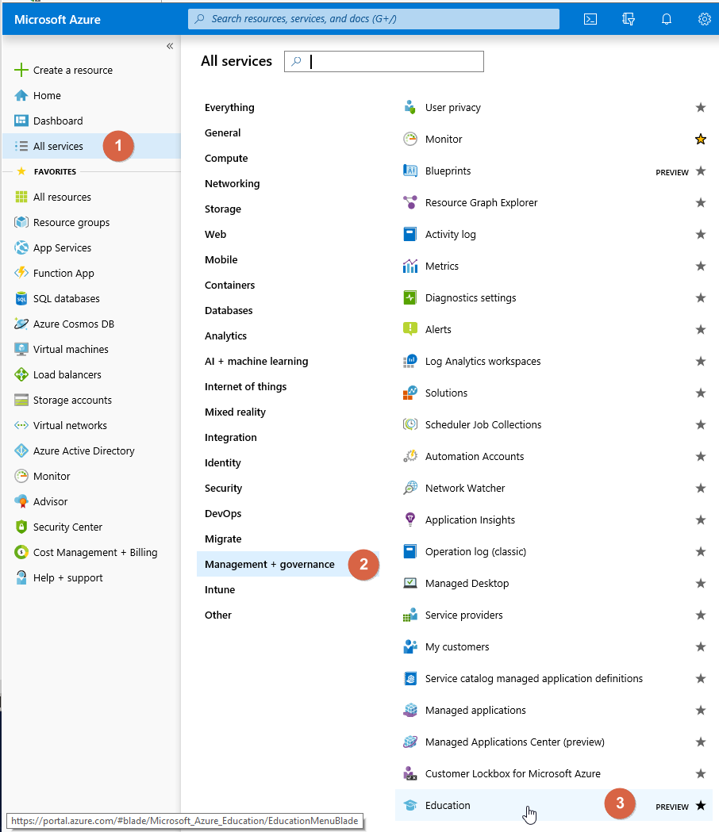

1. On the left navigation menu click All Services.
2. Click on Management + governance.
3. Click Education.

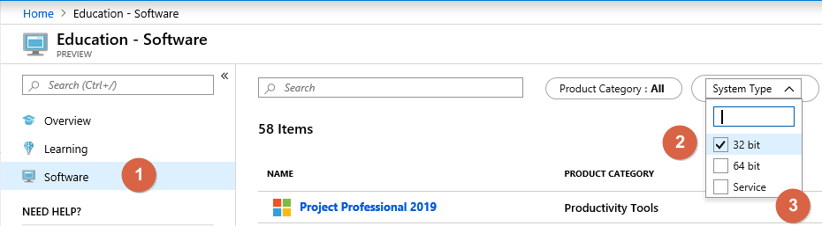

1. Click Software.
2. Change the System Type to match the bitness of your Installed Microsoft Office Professional Plus version. It is recommended that 32bit be the base install for Office, Visio, and Project.
   1. Windows 10 Learning Environment Version 3 has Office 2019 Professional Plus 32bit installed.
3. Download and install the software appropriate software for your class.

For most classes Microsoft Office 2016 for Mac will not be suitable substitute for the Windows versions of the Microsoft Office Suite. Versions designed for macOS **do not** have Microsoft Access, and most Excel macros, Excel Solvers and plugins will not work for macOS version of Office. There are tools available to enable your Mac to work for School of Business classes.

* [OPIM Virtual Desktop](https://confluence.uits.uconn.edu/confluence/display/BUSNIT/OPIM+Virtual+Desktop) (OVD) is a virtual desktop solution for students in select OPIM/MSBAPM courses. This environment is different than UConn AnyWare or OPIM Virtual Desktop (OVD) and includes a number of software packages not available on either.
* [UConn AnyWare](https://software.uconn.edu/uconn-software-online/) provides a virtual lab accessible anywhere, anytime and on any device (software installation is not possible on virtual lab PCs).
* School of Business ITS created a [Windows 10 Learning Environment](https://confluence.uits.uconn.edu/confluence/display/BUSNIT/Windows+Learning+Environment) which students will access by installing either VirtualBox or VMware Fusion on their Macs.

Hypervisor-Management software will read and write to a virtual disk, saved locally on their Macs, containing the Windows Learning Environment. In roughly 20 minutes Mac users will have a working Windows 10 Operating System with Office 2016 for Windows hosted on their Macs. Students will be able to install other Windows software required for classes as necessary which is restricted on UConn AnyWare or OPIM Virtual Desktop. Also because the virtual disk is stored locally it will work even if UConn AnyWare goes offline or students don't have Internet access. Please go to this link for details, <https://confluence.uconn.edu/pages/viewpage.action?pageId=44007511>.

The latest version of the Windows 10 Learning Environment Appliance is available for download here:

<http://static.business.uconn.edu/win10/4VBOX.zip>